Facilities, Equipment and Other Resources
Maximus Energy Corporation operates its own lab space located at 6528 Trail Blvd, Naples, FL 34108. The lab is fully equipped with a wide range of equipment including:
- A wide variety of NaI(Tl) gamma radiation detectors;
- A wide variety of ³He proportional neutron counters;
- Numerous multi-channel analyzers and digital oscilloscopes;
- Numerous Ortec and Canberra bias supplies, preamplifiers and pulse-shaping amplifiers;
- Numerous AmpTek x-ray detectors and pulse processors;
- Several Ortec and Canberra HPGe detectors;
- Varian, Leybold and Pfeiffer turbomolecular pumps and pumping systems, including vacuum gauges and gauge controllers;
- Spellman high voltage power supplies;
- MKS residual gas analyzers;
- Aspex PSEM scanning electron microscope;
- Canberra tritium detectors;
- Variety of Fisher/Branson sonicators, acoustic horns and power supplies;
- Multitude of vacuum parts and supplies;
- SympaTec HELOS laser diffraction particle size analyzer;
- MicroTrac Nanotrac digital light scattering particle size analyzer.
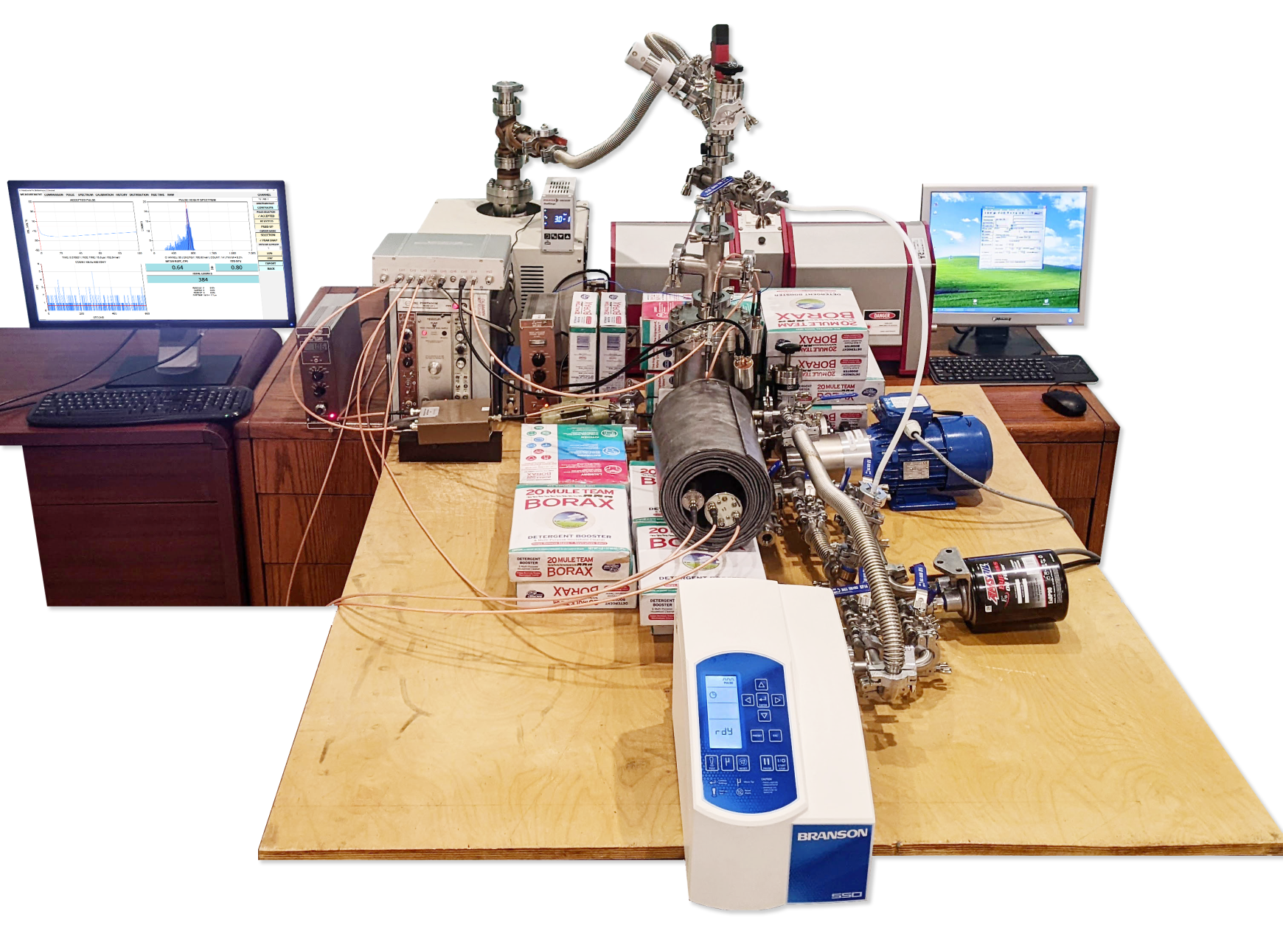
Fig. 1. The experimental fusion reactor at Maximus Energy lab.

